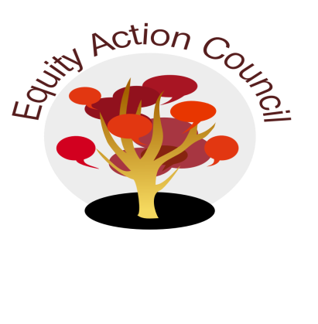
Time | Topic | Process | Facilitator(s)
1:30 pm | I | I. Introduction: Conocimiento and Check In | Alicia Cortez Edmundo Norte
1:45 pm | I/D | II. Institutional Metrics (Draft) | Alicia Cortez
1:55 pm | I/D | IV. FHDA PD Chief Advisory Board | Danny Acosta
2:05 pm | I/D | III. Subcommittee Report:  - DASB/ICC  - Equity Champion Award  - Outreach Conferences (African American, Latinx, API, UndocuWelcome, HEFAS, Student Voices 4 Change, Rock the School lBells) | Stephanie Djuarsa + Anh Doan  Erick Aragon, Hyon Chu Yi-Baker & Adriana Garcia  Erick Aragon
2:50pm | I | IV. Announcements  - March 5 [10am-4pm @ Conf Rm A+B]: Global Issues  - March 8 + 15 [10am-2:30pm @ MLC 250]: Mental Health First Aid  - March 11 [1:30-3pm @ MLC 250]: Ancestral Pilipinx/Pin@y Medicine  - March 19 [1:30-3:30pm + May 16 [12:30-2:30pm] Cultural Humility by Veronica Neal  - Appreciations | All

EAC Community Agreements
Show up, and choose to be present
Pay attention to what has heart and meaning
Tell the truth without blame or judgment
Be open to outcome, not attached to outcome
From The Four-Fold Way® by Angeles Arrien, Ph.D.

